WELCOME TO
Türkiye for the “2.nd Turan Cup” International Tournament
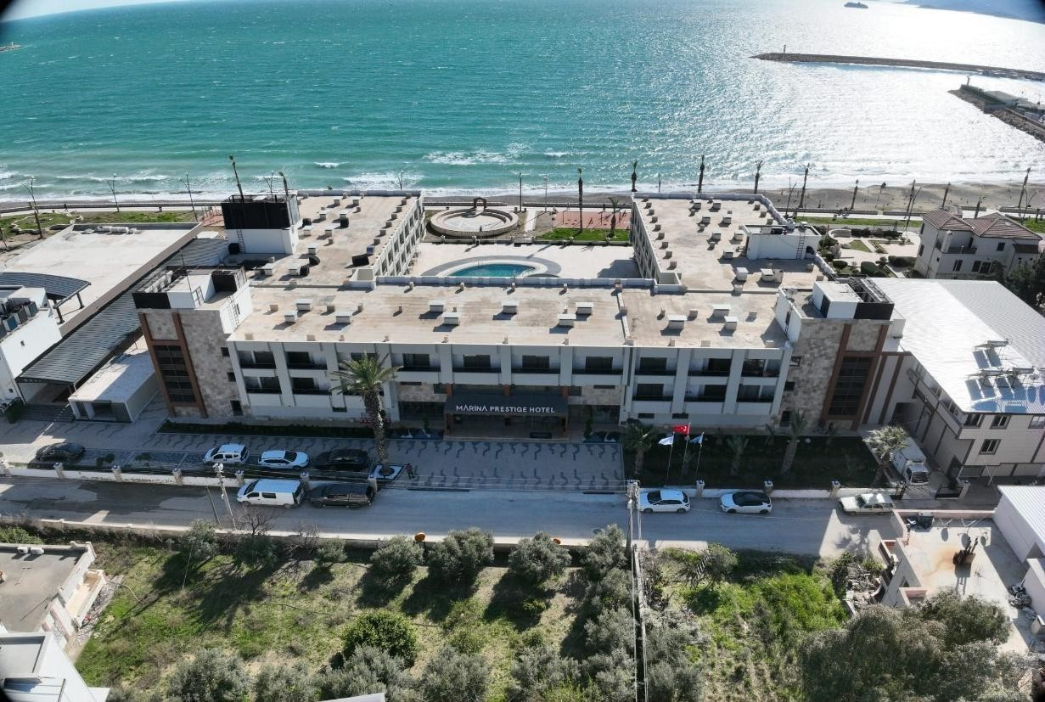
1st – 3rd May 2026


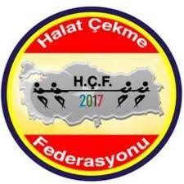

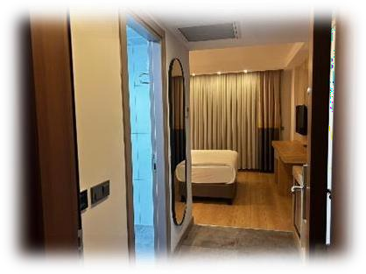

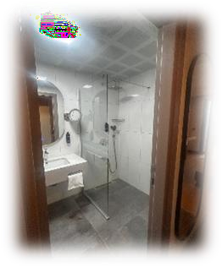


PARTICIPATING COUNTRY PAYMENT SCHEDULE
The participation fee is 100 Euro per person. No additional fees will be requested for airport transfers, local transportation, accommodation, breakfast, lunch, or dinner. All-inclusive hospitality will be provided by the host federation.

FEDERATION BANK ACCOUNT INFORMATION:

T.C. Ziraat Bankası Mersin Pozcu Branch Euro account Swift Code: TCZBTR2AMER
İban No: TR81 0001 0014 0284 4204 8550 04

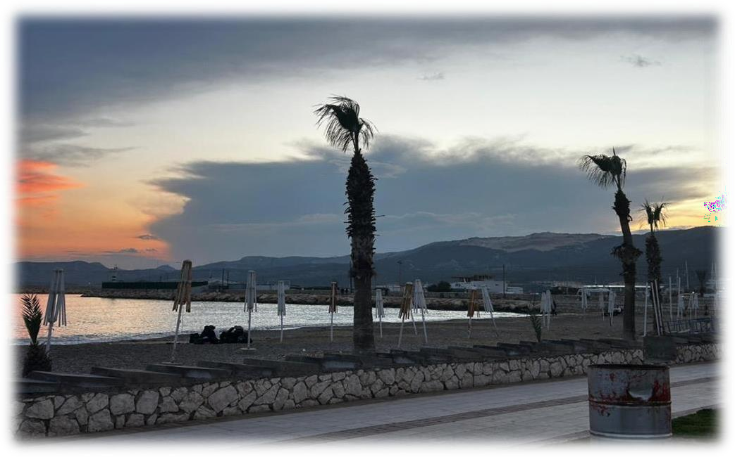
Taşucu, located in the Silifke district of Mersin, is one of the most peaceful and natural coastal settlements on the Mediterranean. Its azure sea, tranquil bays, and clean beaches attract both domestic and foreign visitors, especially during the summer months. However, what makes Taşucu special is not only its sea; it is also its history, nature, and port culture.

Taşucu is one of Turkey's important maritime gateways. Thanks to its port, regular ferry services operate to the Turkish Republic of Northern Cyprus. In this respect, Taşucu is not only a holiday resort but also an international transit point.

The region is situated in a unique geography where the Taurus Mountains extend to the Mediterranean. Therefore, it is suitable for both sea tourism and nature walks. The surrounding bays offer clear waters for diving enthusiasts, while boat tours give visitors the opportunity to discover hidden paradises.
The immediate surroundings of Taşucu are also rich in historical treasures. Thanks to its proximity to ancient settlements such as Silifke, Uzuncaburç, and Kızkalesi, the region also holds an important position in terms of cultural tourism. Walking along the coast on summer evenings, watching the sunset, and enjoying Mediterranean cuisine at seaside fish restaurants are some of the most enjoyable moments in Taşucu.

In short, Taşucu, with its preserved natural structure, tranquil atmosphere, and strategic port location, is one of Mersin's gems waiting to be discovered.

CHAMPIONSHIP PROGRAMME

The 2nd Turan Cup Tug-of-War Championship will be held in Mersin between May 1-3, 2026.

CHAMPIONSHIP SCHEDULE ;
Day 1 : 01 May 2026

Hotel check-in and Registrations | 01.05.2026 |  | 07.00-12.00
Breakfast | 01.05.2026 | Friday | 07.00-10.00
Free time | 01.05.2026 | Friday | 10.00-12.00
Lunch and free time | 01.05.2026 | Friday | 12.00-17.00
Scales of teams | 01.05.2026 | Friday | 17.30-19.00
Technical & Referee meeting | 01.05.2026 | Friday | 19.00-19.30
Match Draw | 01.05.2026 | Friday | 19.30-20.00
Dinner | 01.05.2026 | Friday | 20.00-22.00
Free time | 01.05.2026 | Friday | 22.00-24.00

Day 2: 02 May 2026
Opening Ceremony and Qualifying Competitions will be held in Mersin / TÜRKİYE.

Breakfast | 02.05.2026 | Saturday | 07.00-09.00
Qualifying Matches | 02.05.2026 | Saturday | 10.00-12.00
Lunch | 02.05.2026 | Saturday | 12.00-13.00
Championships Ceremony | 02.05.2026 | Saturday | 13.00-13.30
Qualifying - Quarter final matches | 02.05.2026 | Saturday | 13.30-15.00
Final matches & award ceremony | 02.05.2026 | Saturday | 15.00-19.00
Dinner | 02.05.2026 | Saturday | 19.00-21.00
Turkish Cultural Night | 02.05.2026 | Saturday | 21.00-23.00
Free time | 02.05.2026 | Saturday | 23.00-24.00

Day 3: 03 May 2026
Departure of the groups - Airport transfer procedures.

Breakfast | 03.05.2026 | Sunday | 07.00-09.00
Departure from the hotel | 03.05.2026 | Sunday | 10.00-12.00

PARTICIPATING COUNTRIES AND ATHLETES:
All countries that will participate in the championship can compete in the following weights and categories:

SENIOR MEN | SENIOR MEN | SENIOR MEN-WOMEN MIX
540 Kg. ( 6 athletes ) | 480 Kg. ( 6 athletes ) | 450 Kg. ( 6 athletes )

U-23 MEN WEIGHT |  | U-23 MEN-WOMEN MIX WEIGHT
450 Kg. ( 6 athletes ) |  | 420 Kg. ( 6 athletes )

Participating countries have to make reservations and payments before 20th of April 2026.



Tug of War Federation / TÜRKİYE
For questions and booking:
info@halatcekme.org.tr

www.halatcekme.org.tr

